1. **Characterizing Contexts for Protection**

[HOT’s Ethical Data and Protection Policy](http://placeholder) requires a Protection Risk Assessment for all new field mapping projects. The New Project Ethical Data and Protection Checklist refers to a Context Characterization toolkit. What is that?

This document is supplemental to the [HOT Context Characterization Tool](http://placeholder), a single slide with a quick visual overview of various types of contexts and their level of Protection risk. The slide provides a visual reference, and the following pages more detailed discussion and explanation of the characterizations.

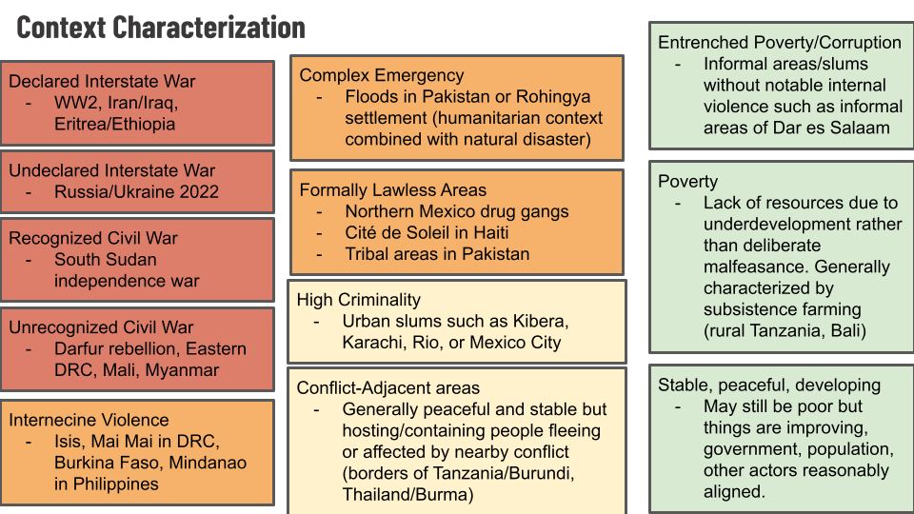

*The HOT Context Characterization tool (also available as an editable presentation slide)*

# Additional Explanation and Details

We can’t simply categorize a context as “conflict or not.” Here are some broad categories of contexts:

* **Declared interstate war** in which two states formally enter into a state of war with official declarations. This almost never happens anymore[1]. Humanitarian law and principles apply without the shadow of a doubt.
  + Example: WW2, the Iran/Iraq war, Eritrea and Ethiopia until 2000,[2]
* **Undeclared interstate war** in which two states enter into a recognizable cross-border conventional military shooting conflict.
  + example: Russia/Ukraine conflict 2020, which Russia refers to as a “special military operation” and Ukraine refers to as a war but hasn’t officially declared it, the US-led wars in Iraq and Afghanistan
    - Formally this seems to mean that the rules of war do not apply (Geneva Conventions re treatment of POWs etc are often ignored by the warring parties), but in practice the laws of war do/should apply.
    - In practice, for example, the Russia/Ukraine conflict in 2020 is unambiguously an interstate war (the UN basically recognizes it at such[3]) and humanitarian law and principles apply.
* **Recognized civil war** in which opposition is acknowledged by actors such as the ICRC as being in de facto control of some areas[4]
  + Example: South Sudan (which ended with South Sudan successfully seceding and founding a new nation-state recognized by the UN).
  + Without recognition of effective opposition control of an area, and some other criteria showing that they actually govern, ICRC is prohibited by their charter from intervening without the consent of the national government, though other humanitarian actors such as MSF have different constraints and may still intervene without government permission.
  + Humanitarian principles apply.
* **Unrecognized civil strife** in which opposition is *not* in effective control of territory according to, for example, ICRC criteria, but is still organized and has a defined hierarchy and political objective
  + Example: rebels in Darfur, Sudan, opposition in some areas of the Democratic Republic of the Congo such as Katanga, who could/would probably form their own governments if they prevailed
  + Humanitarian principles may apply, but many agencies do not observe neutrality, independence, impartiality (UN agencies often explicitly work with government and do not acknowledge opposition as legitimate interlocutors)
* **Internecine violence** in which the opposition does not have defined political goals, hierarchy, or make any real attempt at governance. This may include religious insurgencies or even effectively criminal gangs; the key distinguishing attribute is that they probably could/would not govern in any recognizable fashion if they prevailed
  + Examples: ISIS, Mai Mai in DRC, Lord’s Resistance Army in northern Uganda prior to 2012 or so, bandit/insurgents in the Central African Republic, slums in Haiti, refugee camps such as Dadaab in Kenya
  + Some agencies observe humanitarian principles, others do not (MSF and ICRC will observe HP, UN agencies usually won’t).
* **Lawless areas** in which criminality or sectarian violence rises to such a level as to create conditions functionally akin to conflict and loss of government control, but do not constitute a recognizable rebellion (may or may not have backing or complicity from states inside or outside of the country)
  + Examples: Drug gangs in Mexico and Guatemala, religious anti-Muslim mobs in India
  + Humanitarian principles do *not* generally apply, though some agencies will still try to be guided by some of them. Sustainable Development Goals are relevant.
* **High criminality** in which there’s basically a functioning state, but it is not effective in controlling violence. Usually associated with corruption; violence may have tacit support or complicity from government, marginalized people generally involved.
  + Examples: Inner cities in the United States of America, urban favelas in Brazil, slums in Mexico City
  + Often no-go areas for NGO staff, particularly internationals
  + Humanitarian principles do not apply. Some actors will still try to be guided by some of them. Sustainable Development goals are relevant.
* **Poverty** in which there’s a functioning state, no violence, lawlessness or high criminality that rises to the level of no-go areas for NGO staff taking reasonable precautions. However, people do not receive the level of protection, services, and rights that they should expect from their government. Corruption often a major factor.
  + Examples: Most rural areas in low-income countries in the equatorial regions, inner cities in low and middle-income countries.
  + Humanitarian principles do not apply. Sustainable Development Goals apply.
    - Corruption and poverty, even if it leads to serious deprivation, does not by itself qualify a humanitarian context. This requires *deliberate* exclusion based on identity.
* **Natural disaster** in which there’s a functioning government that generally takes care of its citizens to at least a basic minimum level, but is hit by a disaster greatly exceeding their capacity to respond.
  + Examples: earthquake in Nepal, typhoon in Philippines (excluding the rebel areas), Ebola in Sierra Leone, Guinea, and Liberia
  + Humanitarian principles not even relevant. Sustainable Development Goals are the guiding principles (along with Universal Medical Ethics in the case of outbreak).
* **Complex Emergency** in which a disaster (outbreak, earthquake, floods, etc) hit a country that meets the criteria of one of the preceding contexts in which humanitarian principles are relevant or apply.
  + Example: earthquake and cholera in Haiti, floods in areas of Myanmar and Bangladesh where Rohingya people are living, Ebola in North Kivu and Ituri provinces of DRC
  + Humanitarian principles must be taken into account, though they may not fully govern any intervention.
* **Conflict-adjacent areas** in which there’s a stable situation, but some people within it are directly affected by conflict as refugees or other.
  + Example: Somali refugees in Kenya,

1. <https://harvardnsj.org/2016/08/why-declarations-of-war-matter/>
2. <https://en.wikipedia.org/wiki/Declaration_of_war> there’s a timeline of declared wars since 1945 here
3. <https://unric.org/en/the-un-and-the-war-in-ukraine-key-information/>
4. <https://www.icrc.org/en/doc/assets/files/other/law10_final.pdf> Slide 5 describes the criteria for the ICRC to recognize opposition/dissident control of an area, which allows them to intervene without the consent of the national government